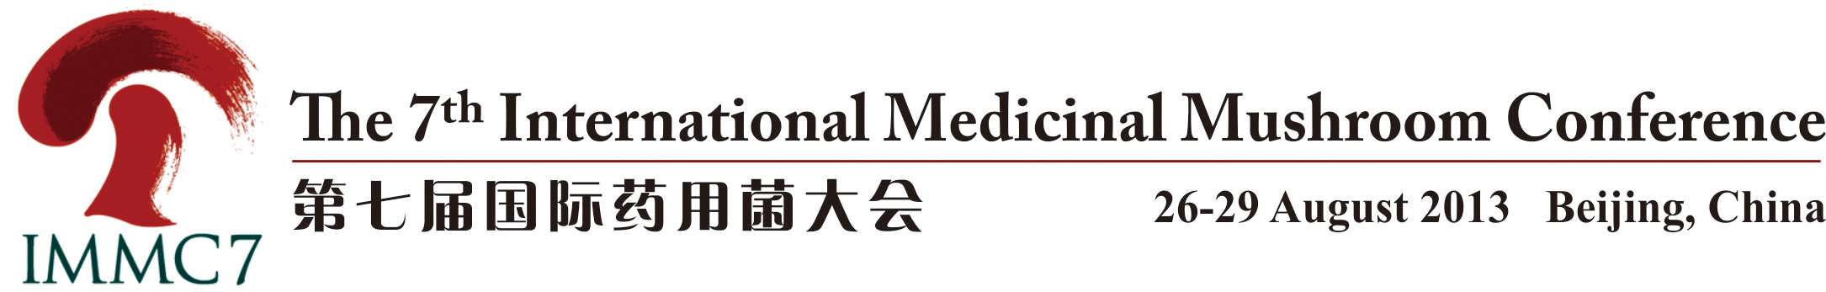

The 7th International Medicinal Mushroom Conference
Final Circular

The international movement for the medicinal mushroom industry marked an important milestone when the International Journal of Medicinal Mushroom (IJMM) was launched in 1999 by Begell House Inc. (USA). This then led to the inaugural International Medicinal Mushroom Conference (IMMC) held in Kiev, Ukraine, in 2001 when it was agreed that there would be an IMMC every two years. The IMMC2 was held in Pattaya, Thailand, in 2003; The IMMC3 was held in Port Townsend, USA, in 2005; and the IMMC4 was held in Ljubljana, Slovenia, in 2007. The IMMC5 was held in Nantong, China, in 2009. In 2011 the IMMC6 was held in Zagreb, Croatia. The IMMC7 will be held in Beijing, China, August 26-29, 2013.

Beijing, the capital city of the People’s Republic of China, is located in the northern part of China, with an area of more than 16,807 square kilometers and a population of 17.5 million. The city is an 800-year-old capital and has an extremely rich historical and cultural heritage, such as the “Beijing Opera”, which is lauded as one of the highest achievements of Chinese culture, and has many places of historic interest like the Great Wall, Forbidden City, Temple of Heaven, Summer Palace, and so on. Beijing not only has glorious ancient civilizations, but it’s also a modern city with high-rise buildings, shopping malls, and a vast amount of international hotels connected by an intricate freeway system throughout the city. Nowadays, Beijing is China’s political, economic, cultural, and educational center. Many international airlines also facilitate Beijing as an important center for international trade and communications. After successfully holding the 2008 Olympic Games, Beijing is becoming more and more attractive and is open to people from all parts of the world.

The theme of the conference: Medicinal mushrooms and their products in global healthcare systems in the 21st century

Organized by:
Chinese Academy Engineering
China Chamber of Commerce of Import and Export of Foodstuffs, Native Produce, and Animal By-Products
Co-organized by:
Agriculture Academic Division of Chinese Academy of Engineering
Jiangsu Alphay Bio-Technology Co., Ltd.
Engineering Research Center of Chinese Ministry of Education for Edible and Medicinal Fungi
Associated Co-Organizer:
Xiaotangshan Modern Agricultural Technology Demonstration Park of Beijing Changping District
Jilin Agricultural University
Jiangsu Suwei Institute of Microbiology
Beijing Booming Biotechnology Co., Ltd.
Institute of Agricultural Resources and Regional Planning, Chinese Academy of Agricultural Sciences
Engineering Research Center for Mushroom Industry, CAAS
National Engineering Research Center of Edible Fungi
Shanghai Academy of Agricultural Sciences
Edible Fungi Branch of Chinese Association of Agricultural Science Societies
Edible Fungi Association of Jiangsu Province
Edible Fungi Institute of Fujian Academy of Agricultural Sciences
Fujian Society of Edible Fungi
Guangdong Institute of Microbiology
Guangdong Edible Fungi Association

Media Partners:
www.emushroom.net
www.emmushroom.com

Organization
Local Organizing Committee
Honorary Chairmen: Prof. S. T. Chang, Prof. S. P. Wasser
Chairman: Prof. Yu Li
Executive Chairman: Mr. Hui Chen
Vice Chairman: Mr. Zhenhu Bian, Mr. Shengjun Yang
Secretary General: Mr. Ziqiang Liu, Mr. Zhongqi Gao

International Scientific Committee
Prof. S.T. Chang (Australia)
Prof. S.P. Wasser (Israel/Ukraine)
Prof. Yu Li (China)
Prof. Xu Liu (China)
Prof. Lorna Casselton (UK)
Prof. Ursula Kües (Germany)
Prof. Zhibin Lin (China)
Prof. Keto E. Mshigeni (Tanzania)
Dr. Ivan Jakopovich (Croatia)
Prof. Franc Pohleven (Slovenia)
Prof. Dr. Marin Berovic (Slovenia)
Prof. L. J. L. D. van Griensven (the Netherlands)
Dr. John Holliday (USA)
Prof. Omon S. Isikhuemhen (USA/Nigeria)
Prof. Naohito Ohno (Japan)
Prof. Ulrike Lindequist (Germany)
Prof. Ha Won Kim (Korea)
Dr. Hui-Chen Lo (Chinese Taipei)
Dr. Vinay K. Varshney (India)
Prof. Peter C.K. Cheung (Hong Kong, China)
Dr. Paul Stamets (USA)
Dr. Nadezhda V. Psurtseva (Russia)
Prof. Vikineswary Sabaratnam (Malaysia)
Dr. Angela Amazonas (Brazil)
Ms. Carmenza Jaramillo (Colombia)
Prof. Chii-Hyun Song (Korea)
Dr. RD Rai (India)
Dr. Sheng-Hua Wu (Chinese Taipei)
Dr. Bor-Cheh Wang (Chinese Taipei)
Prof. Yongsheng Che (China)
Prof. Burtan Yang (Canada)
Prof. Hirokazu Kawagishi (Japan)
Prof. Yijian Yao (China)
Prof. Hexiang Wang (China)
Prof. Jinsong Zhang (China)
Prof. Xiaotong Yang (China)
Prof. Junfang Lin (China)

Publications Committee

Prof. S.P. Wasser (Israel/Ukraine)
Prof. Yu Li (China)
Prof. Yijian Yao (China)
Prof. Mingjie Chen (China)
Prof. Junfang Lin (China)
Prof. Jichuan Kang (China)

Programs of the conference
A. Keynote speeches
Chairmen: Prof. Yu Li (China), Prof. Ulrike Lindequist (Germany)
1. Prof. S.T. Chang (Australia)
Modern Views on Mushroom Biotechnology and Impact on Global Welfare with Special Attention on China
2. Prof. S.P. Wasser (Israel/Ukraine)
Modern Views on Current Status, Future Trends, and Unsolved Problems in Medicinal Mushroom Science

Chairmen: Prof. S.P. Wasser (Israel/Ukraine), Prof. Zhibin Lin (China)
3. Prof. Ursula Kües (Germany)
Mating Type Genes as Master Regulators of Mushroom Development
4. Prof. Yongsheng Che (China)
Lessons from the Success of Fingolimod, a Blockbuster Drug Derived from a Metabolite of Isaria sinclairii

B. International Top-level Forum on Engineering Science and Technology Development--- Medicinal Mushrooms
International Top-level Forum of Chinese Academy of Engineering (CAE) on Engineering Science and Technology Development - Medicinal Mushroom will be held on August 26, 2013 in Jiuhua Resort and Convention Center, Beijing, which was sponsored by CAE and organized by the China Chamber of Commerce of Import and Export of Foodstuffs, Native Produce, and Animal By-Products, Jiangsu Alphay Bio- Technology Co., Ltd., and Engineering Research Center of Chinese Ministry of Education for Edible and Medicinal Fungi, Jilin Agricultural University.
Intending to integrate research, business and industry, as well as upgrade the medicinal mushroom industry in China, several top international scientists will deliver their opinions on perspectives or development towards various frontier topics and interdisciplinary subjects in this field.
- Forum Theme
Mushroom - Health - Future
- Organization in Collaboration
Sponsored by: Chinese Academy of Engineering
Organized by: China Chamber of Commerce of Import and Export of Foodstuffs, Native Produce, and Animal By-Products
Jiangsu Alphay Bio-Technology Co., Ltd.
Engineering Research Center of Chinese Ministry of Education for Edible and Medicinal Fungi, Jilin Agricultural University.
- Keynote speeches
Chairmen: Prof. Yu Li (China), Prof. Keto E. Mshigeni (Tanzania)
Professor S. T. Chang (Australia/HongKong): Merits of Mushroom Industry in Human Welfare
Professor S. P. Wasser (Israel/Ukraine): Modern View on Current Status, Future Trends, and Unsolved Problems in Medicinal Mushrooms Science
Professor Dr. Ulrike Lindequist (Germany): Pharmaceutical Aspects of Medicinal Mushrooms
Chairmen: Prof. Zhibin Lin (China), Prof. Jinsong Zhang (China)
Professor Yu Li (China): Mushrooms, an Emerging Health Industry
Professor L. J. L. D. van Griensven (Netherland): Mushrooms: a Healthy Business. What Are the Requirements?
Professor Chee-Jen Chen (Chinese Taipei): Taiwan Edible and Medicinal Mushrooms in Biotech-Healthcare Industry
- Academic discussions
Chairmen: Prof. S.P. Wasser (Israel/Ukraine), Prof. Jichuan Kang (China)
Professor Keto E. Mshigeni (Tanzania): Medicinal Mushroom as A Remedy for HIV/AIDS and Cancers: Their Promise
Professor Yijian Yao (China): Conservation and Utilization of Medicinal Mushroom Resources
Professor R.D.Rai (India): Topic to be determined
Mr. Hui Chen (China): Business Growth of Alphay - Following With the Development of Medicinal Mushroom Industry in China
Chairmen: Prof. Yi-jian Yao (China), Prof. R.D.Rai (India)
Professor Dr. Marin Berovic (Slovenia): Topic to be determined
Professor Jichuan Kang (China): The Risen of Medincal Mushroom in Pharmaceutical Industry
Dr. Angela Amazonas (Brazil): Brazilian Medicinal Mushroom Agaricus brasiliensis
Professor Hongwei Liu (China): Deep Prospecting and Understanding of the Medicinal Mushroom - From the Viewpoint of Chemical Constituents

C. Scientific Forum on Medicinal Mushrooms
C1. Potential Values of Medicinal Mushroom Products
Co-convener: Prof. Vikineswary Sabaratnam (Malaysia), Prof. Jichuan Kang (China) Prof. L. J. L. D. van Griensven (the Netherlands), Prof. Xiaotong Yang (China) Prof. Ha Won Kim (S. Korea), Prof. Haiying Bao (China)
Dr. Viney K. Varshney (India), Ms. Carmenza Jaramillo (Colombia)
Prof. L. J. L. D. van Griensven (the Netherlands ): Phellinus linteus polysaccharide extracts increase mitochondrial membrane potential (MMP) and cause THP-1 monocytes to undergo apoptotic death, peripheral blood monocytes (PBMC) to differentiate into macrophages
Prof. Ha Won Kim (S. Korea): Immunological host defence mechanism and applications of fungal β-glucans by employing dectin-1 receptor in the innate immunity
Prof. Jichuan Kang (China): Current status of medical application of Cordyceps sensu lato
Prof. Vikineswary Sabaratnam (Malaysia): Fibrinolytic and anticoagulant enzymes of selected medicinal and culinary mushrooms
Prof. Wai-Jane Ho (Chinese Taipei): the growth requirements of a medicinal fungus xylaria nigripes
Prof. Haiying Bao (China): Research on traditional Chinese mycomedica Inonotus sanghuang
Ms. Carmenza Jaramillo (Colombia): Implementation of the edible mushroom Pleurotus spp. as a nutritional alternative for children and seniors in communal cafeterias
Prof. Changtian Li (China): In vitro inhibitory effects on mushroom tyrosinase by Inonotus obliquus
Dr. Viney K. Varshney (India): cultivation of different isolates of medicinal chinese caterpiller mushroom, ophiocordyceps sinensis (berk.) g.h. sung. et al. and their tlc-densitometric assessment for cordycepin content

C2. Science and Technology (including Germplasm Resources, etc.)
Co-convener: Prof. Ulrike Lindequist (Germany), Prof. Junfang Lin (China)
Prof. Dr. Franc Pohleven (Slovenia), Dr. Shenghua Wu (Chinese Taipei)
Dr. Nadezhda V. Psurtseva (Russia), Prof. Changtian Li (China)
Prof. Dr. Franc Pohleven (Slovenia): Activity of Cordyceps militaris water extract in the cells of yeast Saccharomyces cerevisiae
Prof. Naohito Ohno (Japan): Fungal beta-glucans modulate innate as well as acquired immunity
Prof. Qi Wang (China): A review of the chemical metabolites and their activities from myxomycete
Dr. Nadezhda V. Psurtseva (Russia): Culture collections: germplasm resources for medicinal mushrooms science and production

C3. New Development in Dietary Supplements
Co-convener: Dr. Hui Chen Lo (Chinese Taipei), Prof. Peter Cheung (Hong Kong, China)
Dr. Hui Chen Lo (Chinese Taipei): Medicinal mushrooms for glycemic control in diabetes mellitus
Dr. Boris Jakopovich (Croatia): Effects of medicinal mushroom extracts on bone remodeling
Prof. Peter Cheung (Hong Kong, China): New development in dietary supplements

C4. Quality Control and Regulations
Co-convener: Prof. S.P. Wasser (Israel/Ukraine), Dr. Ivan Jakopovich (Croatia)
Prof. Dr. Ulrike Lindequist (Germany): The merit of medicinal mushrooms in medicine from a pharmaceutical point of view
Prof. Zengtao Xing (China): General introduction of mushroom quality and foodsafety management of China
Prof. Yan Yang (China): Flavour components and its identification methods of edible and medicinal mushrooms

C5. Industrial Production and Marketing
Co-convener: Prof. Jinchu Chen (Chinese Taipei), Ms. Yi Liang (Canada)
Prof. Jinchu Chen (Chinese Taipei): Immunoregulatory role of Pleurotus eryngii superfine powder and its anti-tumor activity
Prof. Jeng-Leun Mau (Chinese Taipei): Edible and medicinal mushrooms, their fermented and processed products
Dr. R.D. Rai (India): Research, production and trade of medicinal mushrooms in India
Ms. Yi Liang (Canada): Health. Wealth. Humanity. New strategic opportunities for integrating industrial production and marketing systems for global expansion
Dr. Angela Amazonas (Brazil): Production and marketing of edible and medicinal mushrooms in brazil: current status, opportunities and future trends
Ms. Nailoke Pauline Kadhila-Muandingi (Namibia): Industrial production and marketing for medicinal mushrooms

C6. Technology of Cultivation and fermentation
Co-convener: Prof. Marin Berovic (Slovenia), Prof. Zengzhi Li (China)
Prof. Hexiang Wang (China), Prof. Lean-Teik Ng (Chinese Taipei)
Prof. Marin Berovic (Slovenia): Production of pharmaceutical compounds of medicinal fungi in bioreactors
Prof. Zengzhi Li (China): Technology of cultivation and fermentation of Cordyceps spp. s. l.
Prof. Kelvin Leung (Hong Kong, China): Current evidence for the hepatoprotective activity of the medicinal mushroom Antrodia cinnamomea
Prof. Hexiang Wang (China): Biological activities of mushroom lectins and polysaccharides
Prof. Lean-Teik Ng (Chinese Taipei): Elite Antrodia cinnamomea strain selection, cultivation and anti-hepatoma properties of its fruiting bodies
Prof. Yang Pan (China): Research progress on fermentation processing to attenuate toxicity and synergize effect of toxic chinese materia medica

D. Satellite Symposia:
D1. Ganoderma spp.: Perspectives and challenges
Co-convener: Prof. Zhibin Lin (China), Prof. Keto E. Mshigeni (Tanzania)
Dr. Angela Amazonas (Brazil), Prof.Yucheng Dai (China)
Dr. R.D. Rai (India), Prof. Jinsong Zhang (China)
Prof. Zhibin Lin (China): Anti-oxidative and free radical scavenging activity of Ganoderma lucidum and its significance
Prof. Keto E. Mshigeni (Tanzania): Ganoderma mushrooms: perspectives and challenges
Prof. Jinsong Zhang (China): Progresses and perspectives of Lingzhi Research
Prof. Yucheng Dai (China): Phylogeny and diversity of the Ganoderma lucidum and Inonotus linteus complex
Dr. Jie Kang (China): Advances on phytochemicals from Ganoderma mushroom in recent years
Prof. Zhanxi Lin (China): Study on Ganoderma lucidum cultivated by JUNCAO grass

D2. Ophiocordyceps sinensis, Cordyceps militaris and Isaria cicadae: Perspectives and challenges
Co-convener: Prof. Yijian Yao (China), Prof. Daniel Winkler (USA)
Prof. Chengshu Wang (China), Prof. Zuoyi Liu (China)
Prof. Yijian Yao (China): Ophiocordyceps sinensis - recent research progress and future prospects
Prof. Daniel Winkler (USA): Steps towards sustainable management of Ophiocordyceps sinensis - caterpillar fungus
Prof. Zuoyi Liu (China): Studies on the active components of Cordyceps gunnii
Prof. Chengshu Wang (China): So close, so different: comparative genomic analysis of Ophiocordyceps sinensis and Cordyceps militari

D3. Taiwanofungus camphoratus and other medicinal mushroom (Hericium erinaceus, Trametes versicolor, Grifola frondosa): perspectives and challenges
Co-convener: Prof. H. Kawagishi (Japan), Prof. Chee-Jen Chen（Chinese Taipei）
Prof. H. Kawagishi (Japan): Gargalols a, b and c, osteoclast-forming suppressing compounds from the edible mushroom Grifola gargal
Dr. Shenghua Wu (Chinese Taipei): Inonotus sanghuang: perspectives and challenges
Prof. Airong Song (China): In vitro anti-influenza virus activities of natural products isolated from Phellinus igniarius, Antrodia cinnamomea and Griflola frondosa in submerged culture
Prof. Zhenming Lu (China): Efficient submerged fermentation of Taiwanofungus camphoratus with a modified inoculation method
Prof. Shuyan Liu (China): the antifungal activity of hericium erinaceus on four plant pathogens

D4. Mating genes in mushrooms
Co-convener: Prof. Ursula Kües (Germany), Prof. Mingjie Chen (China)
Prof. Mingjie Chen (China): A primary study on mating gene of Volvariella volvacea
Prof. Yingbin Bian (China): Mating type loci and mating genes in mushrooms
Prof. Baogui Xie (China): The genome of Tremella fuciformis and its cohabitant fungus (Hypoxylon stygium) provides insights into their contribution on carbohydrate degradation
Prof. Anastasia Shnyreva (Russia): The mata mating type locus of Pleurotus ostreatus
Prof. Fangjie Yao (China): The research progress in the mating type genes structure and evolution of basidiomycete
Prof. Chenyang Huang (China): Mating type factors of Pleurotus eryngii var. tuoliensis

D5. Medicinal mushrooms in animal production and health
Co-convener: Prof. Omon S. Isikhuemhen (USA /Nigeria), Dr. Yongqiang Wang (China)
Prof. Omon S. Isikhuemhen (USA /Nigeria): Current trends in medicinal mushrooms use in animal health and production
Dr. Yongqiang Wang (China): Effect of dietary supplementation on improvement of growth and immune function of broilers
Prof. Chunfeng Wang (China): Study on exploitation and pharmacological effect on edible and pharmacological mushroom polysaccharides

E. Poster
Posters should include title, authors and relevant institutions, introduction, materials and methods, results and discussion, and main references.
The poster size should not exceed by 80×110 cm (width × height).

F. International Mushroom Expo
Offering 32 standard stands (3m×3m) and 5 special stands to exhibit mushroom products and the latest research.
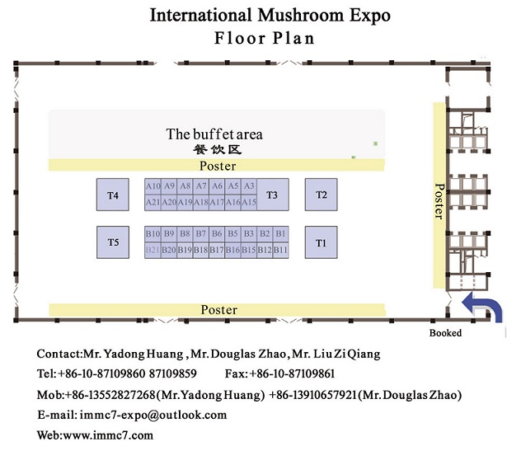
Date and Location
The 7th International Medicinal Mushroom Conference (IMMC7) will be held in Beijing, China, August 26-29, 2013.

Deadlines
15 August 2013 PPT and speech draft collection

For more information visit www.immc7.com

Conference and meal fees
Registration fees
Registration fees for early bird discount (before 25 July 2013):
US$415 for regular attendees
US$295 for students (with student card) and accompanying person
Tips: Registration and/or transfer fees after July 25th will be as follow:
US$485 for late registrants of regular attendees
US$365 for late registrants of students (with student card) and accompanying person
Conference fee includes: admission to all scientific sessions, free entrance to the conference exhibition, conference bag and registration documents, including printed program and Book of Abstracts, Book of Proceedings, scientific excursion, visit to the Ming Tombs and the Juyongguan Pass of the Great Wall.

Meal fees
US$288 for all attendees
The meal fee for a delegate covers the following:
- Welcome reception
- Lunches and dinners during the conference
- Closing Ceremony
- Coffee breaks
- Conference banquet

If you have any question about registration, please send E-mail to immc7@outlook.com.

Exhibition fees
Offering 32 standard stalls (3m×3m) to exhibit mushroom products and the latest research. Every standard stand fee is USD 2,005.00, including one attendee’s conference fee.
If you have any question about exhibition, please send E-mail to immc7-expo@outlook.com.

Payment
All payment from non-PRC participants should be in US dollars.
Payment can be made using a Bank Draft, Bank Transfer. Please refer to the following bank information:
BENEFICIARY: RHYTHM GLORY (HONG KONG) LIMITED
BENEICIARY’S BANK: The Hong Kong and Shanghai Banking Corporation Limited HONGKONG
AdDress: 1Queen’s Road Central, Hong Kong
A/C NO: 848-188462-838
SWIFT BIC：HSBCHKHHHKH

If you have any question about payment, please send E-mail to immc7@outlook.com.

Cancellation Policy:
Cancellation of registration should be sent in writing to the Secretariat by E-mail (immc7@outlook.com).
An administrative charge will be deducted from the amount, according to the date the cancellation letter is received. All refunds will be processed after the Conference. Registration fees are not transferable.
Cancellation on or before May 1, 2013: 80% refund.
Cancellation on or before July 1, 2013: 50% refund.
Cancellation after Auguest 1, 2013: no refund.

Accommodation
Hotels and Rates: A number of hotel rooms have been reserved at a special discount rate for symposium participants. Only bookings made through the Symposium Secretariat can take advantage of these rates. All rates are inclusive of taxes and services.
Date | Name of Hotel | Type of room | Room rate
August 25-30 | Jiuhua Resort and Convention Center(16 area,5*) | Standard room | US$88/day
August 25-30 | Jiuhua Resort and Convention Center(16 area,5*) | Queen suite | US$88/day
August 25-30 | Jiuhua Resort and Convention Center(16 area,5*) | Business suite | US$165/day
August 25-30 | Jiuhua Resort and Convention Center(10 area,4*) | Standard room | US$75/day
Hotel Reservation: Please complete the registration form and send it to the conference Secretariat. The Symposium Secretariat will handle your reservation before 25 July 2013.
Notes:
1. The room rate includes service charge (tax) and breakfast.
2. For those who intend to share rooms, please write down your roommate's name in the hotel reservation form online.
3. Check-in time is at 1:00 pm and check-out time is at 12:00 am.
4. For those who reserve a room at the Beijing Tangshan Holiday Conference Center, there will be shuttle bus to the symposium’s venue at regular times.
5. Please transfer the hotel fees to the bank as follows:
Company Name: BEIJING JINJIANG INTERNATIONAL TRAVEL CO,.LTD
Address: ROOM 1502, NO.15BUILDING, 89TH YARD, JIANGUO ROAD, CHAOYANG DISTRICT, BEIJING, P.R.C
Bank Name: DAWANGLU BANK OUTLET, BEIJING MUNICIPAL BRANCH
Bank Address: 1ST FLOOR,BLUE CASTLE, NO.3 WEST DAWANGLU CHAOYANG DISTRICT
Account NO. : 110060929018002598502
Swift code: COMMCNSHBJG

If you have any question about accommodations, please send E-mail to: immc7@outlook.com

Accommodations are arranged at Jiuhua Resort and Convention Center (http://www.jiuhua.com.cn/enindex.asp), the symposium’s venue.

The Jiuhua Resort and Convention Center is located in the Changping District of Beijing, 35 kilometers downtown and 26 kilometers from the Beijing Capital International Airport. It covers an area of over 130 hectares and over 2300 hotel rooms of different types, from 3-star to 5-star levels and villas.

The Jiuhua Resort and Convention Center has state-of-the-art convention and exhibition facilities, covering an area of 60,000 square meters. It has more than 100 meeting rooms of different sizes, which can cater to the needs of different types of meetings.

The Jiuhua Resort and Convention Center was built on the old premises of the royal palaces in the Ming Dynasty. It is renowned for hot springs, which come from 1200 meters underground and is rich in strontium, lithium, metasilicate and other beneficial minerals and trace elements. It is the most unique spa theme park in China with hundreds of spas.
The hotel offers:
- an open-air spa swimming pool and an indoor spa swimming pool
- unique spa bath, medicated spa bath, spa swimming and spa sauna
- health club, massage, beauty salon and other services
- a full collection of all eight main flavors of Chinese cuisine
- Western buffet, Korean barbecue and varieties of local snacks
- karaoke bars with classic layout, game rooms with beautiful designs
- bowling alleys, tennis courts, badminton courts, gymnasium, KTV rooms

Jiuhua Resort and Convention Center
Address: Xiaotangshan Township, Changping District, Beijing 102211
Telephone: (+86-10) 6178 2288
Website: http://www.jiuhua.com.cn

For more information visit the conference website at www.immc7.com

Tour of Accompanying Person
Day 1 Tuesday, August. 27th (9:00—18:00)
The Summer Palace--The Temple of Heaven--Hutong (traditional Chinese courtyard houses) keeping the original layout in the Gulou area

Day 2 Wednesday, August.28th (9:00-17:30)
Tiananmen Square (literally, Gate of Heavenly Peace)--Qianmen Street--Yaxiu Market--Silk Market

If you have any question, please send E-mail to immc7@outlook.com

General Information
Language
The official language of the conference is English.
Weather in Beijing
Beijing is located in the temperate zone affected by continental monsoons. The spring and autumn in Beijing are short and dry, while the summer and winter are relatively long. The average daily temperature during the symposium in August is around 18-35°C.

Passport and Visa
A valid passport and a visa are required for entry into China. Visas can be obtained from your local Chinese Embassy or the nearest Consulate General. Japanese and Singaporean participants holding a private passport and staying in China for not more than 15 days do not need a visa. Early registration is advised so that adequate time is allowed for obtaining visas.
To obtain a business visa, participants can provide passport information at online registration and a scanned copy of passport so that the organizer can prepare and send an official visa invitation letter, which lists the city where the applicant should apply for the visa, the passport data, the gender of the applicant and the accompanying persons, the date of entry and length of stay. Alternatively, participants can apply for a tourist visa through a travel agent after booking air tickets and completing the hotel reservation.

Letter of invitation
Requests for formal letters of invitation to attend the IMMC7 should be directed to immc7@hotmail.com. This invitation is only intended to facilitate participants travel and visa arrangments. It implies no provision of any support – financial or otherwise.

Transportation
IMMC7 Address:
Northeast side of the crossing of Shunsha Road (S321) and Ansi Road (S213), Xiaotangshan Town, Changping District, Beijing.
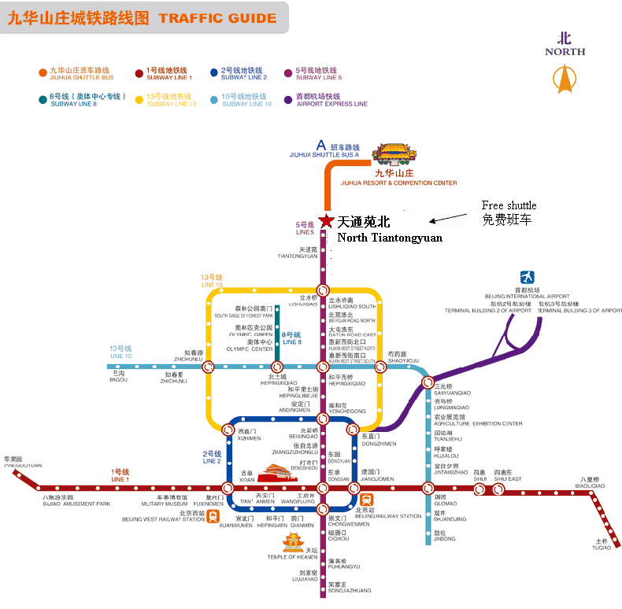
Airplane
The capital’s airport is about 30 km away from the exhibition center. If visitors take taxis, it will take 30 min to get there, and the cost is about RMB 120 Yuan.

Train
Visitors can take the subway and get off at “North Tiantongyuan” Station (Line 5) and then take the free shuttle for the IMMC7. From 9:00-22:00 on Aug. 25th, there are free shuttles per hour at “North Tiantongyuan” Station (the site can be found on the map).

If you have any question, please send E-mail to immc7@outlook.com

Time Table
SUNDAY  8/25/2013 | MONDAY  8/26/2013 |  | TUESDAY  8/27/2013 |  | WEDNESDAY  8/28/2013 |  | THURSDAY  8/29/2013
9:00-22:00 Conference Registration | 7:00-8:30 Breakfast |  | 7:00-8:30 Breakfast |  | 7:00-8:30 Breakfast |  | 7:00-8:30 Breakfast
9:00-22:00 Conference Registration | 9:00-9:45  Opening Ceremony |  | 9:00-10:30  Keynote Speech  Ⅲ, Ⅳ |  | 9:00-10:30 |  | 9:00-11:30
9:00-22:00 Conference Registration | 9:45-10:15  Photo and Tea Break |  |  |  | C1 | D1 | D5 | C4
9:00-22:00 Conference Registration | 10:15-12:00  Keynote Speech  Ⅰ,Ⅱ |  | 10:30-10:45  Tea Break |  | 10:30-10:45  Tea Break |  | 11:30-12:00  Closing Ceremony
9:00-22:00 Conference Registration |  |  | 10:45-12:15  C2 |  | 10:45-12:15
9:00-22:00 Conference Registration |  |  |  |  | C1 | D1
9:00-22:00 Conference Registration | 12:00-13:30 Lunch |  | 12:15-13:30 Lunch |  | 12:15-13:30 Lunch |  | 13:30-18:30  Scientific Excursion
9:00-22:00 Conference Registration | 13:30-19:00  International Top-level Forum on Engineering Science and Technology Development-- Medicinal Mushrooms | 13:30-15:30  C6 | 13:30-15:30  C2 | 13:30-15:00  C3 | 13:30-15:30
 |  |  |  |  | C1 | D1
9:00-22:00 Conference Registration |  | 15:30-15:45  Tea Break | 15:30-15:45  Tea Break | 15:00-15:15 Tea Break | 15:30-15:45  Tea Break
9:00-22:00 Conference Registration |  | 15:45-18:15  C6 | 15:45-18:00  C2 | 15:15-18:30  C5 | 15:45-17:45
 |  |  |  |  | C1 | D2
9:00-22:00 Conference Registration | 19:00-21:00  Welcome Reception |  | 18:00-19:00  Buffet Dinner |  | 18:00-19:00  Buffet Dinner
9:00-22:00 Conference Registration |  |  | 19:00-22:00 |  | 19:00-21:00 |  | 19:00-21:00  Buffet Dinner
9:00-22:00 Conference Registration |  |  | D3 | D4 | C1 | D2

Session C1. Potential Values of Medicinal Mushroom Products
Session C2. Science and Technology (including Germplasm Resources, etc.)
Session C3. New Development in Dietary Supplements
Session C4. Quality Control and Regulations
Session C5. Industrial Production and Marketing
Session C6. Technology of Cultivation and fermentation

SYMPOSIUM D1.Ganoderma spp.: Perspectives and challenges
SYMPOSIUM D2. Ophiocordyceps sinensis, Cordyceps militaris and Isaria cicadae: Perspectives and challenges
SYMPOSIUM D3.Taiwanofungus camphoratus and other medicinal mushrooms (Hericium erinaceus, Trametes versicolor, Grifola frondosa)
SYMPOSIUM D4.Mating genes in mushrooms
SYMPOSIUM D5.Medicinal Mushrooms in Animal Production and Health
The 7th International Medicinal Mushroom Conference
Local Organizing Committee:
Address: 4/F, Talent International Building, No. 80 Guangqumennei Street, Dongcheng District, Beijing 10062, China. P.C.:100062
Tel: +86-10-87109859, 87109860, 87109858
Fax: +86-10-87109861
E-mail: immc7@hotmail.com (Abstract & Full paper);
immc7@outlook.com (Registration, payment & Accommodation)
immc7-expo@outlook.com (Exhibition)
Website: www.immc7.com

